Ectopic Ureters in Dogs
By Catherine Barnette, DVM

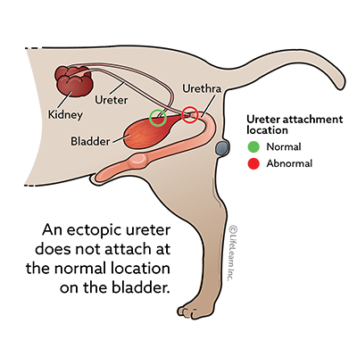
What are ectopic ureters?
An ectopic ureter is an anatomical defect that is present at birth in some dogs. In a dog with ectopic ureters, the ureters do not attach to their normal location in the bladder.
Ureters are small tubes that drain urine from the kidneys to the bladder. Animals have two kidneys; therefore, there are two ureters. In a normal dog, each of these two ureters attaches to the bladder at a specific location. This allows the urine, which is draining from the kidneys on a nearly constant basis, to collect in the bladder until the dog chooses to urinate.
In a dog with ectopic ureters, however, the ureters do not enter the bladder at their usual location. Instead, the ureters drain into the urethra or even into the vagina (in females). This interferes with the bladder’s normal ability to retain urine.

What causes ectopic ureters?
Ectopic ureters are caused by abnormal development in the womb, before the puppy is born. When the embryonic ducts that will eventually become the ureter fail to develop in their normal location, ectopic ureters are the result.
Ectopic ureters are thought to be a hereditary condition in some breeds. The genetic link appears to be strongest in Entlebucher Mountain Dogs. Labrador retrievers, golden retrievers, poodles, Siberian huskies, Newfoundlands, West Highland white terriers, soft-coated wheaten terrier, and other terrier breeds are also more likely to be born with ectopic ureters than dogs of other breeds, which suggests that an unidentified genetic cause may also exist in these breeds.

What are the clinical signs of ectopic ureters?
The most common sign of ectopic ureters is urinary incontinence, or urine dribbling, in a young female dog. While ectopic ureters can occur in males, females are affected far more commonly. Signs are often noticed soon after weaning, although some dogs do not show signs until they reach adulthood. The urine leakage observed with ectopic ureters may be constant or intermittent.
Other signs of ectopic ureters can be more subtle. Affected dogs may frequently lick at the genital area, due to small amounts of urine leakage. They may also have discolored hair around the genitals, caused by urine leakage.
Dogs with ectopic ureters are often prone to repeated urinary tract infections. When the ureters bypass the bladder’s normal sphincter mechanism, bacteria are able to migrate up into the urinary tract more easily. Signs of a urinary tract infection may include frequent urination of small volumes, discomfort or straining when urinating, and abdominal pain. While most urinary tract infections are not associated with ectopic ureters, repeated urinary tract infections in a young dog suggests a need to look for underlying anatomical issues.

How are ectopic ureters diagnosed?
The first test to be performed on any dog with a urinary issue is a urinalysis. This test assesses the chemical composition of the urine, evaluating urine concentration, acidity, protein levels, and the levels of various chemical substances within the urine. Additionally, your dog’s urine will be examined under the microscope, to look for the presence of red blood cells, white blood cells, and urinary crystals. Red and white blood cells suggest the presence of infection or inflammation, while crystals can be either a cause or an effect of urinary tract disease.
Other tests that may be performed to rule out other causes of abnormal urination include urine culture and sensitivity, abdominal radiographs, and abdominal ultrasound. A urine culture and sensitivity test is the most accurate way to determine whether your dog has a urinary infection and, if so, which antibiotics are recommended for treatment. Urinary tract infections are common in dogs with ectopic ureters. Abdominal radiographs are typically normal in a dog with ectopic ureters, but they allow your veterinarian to rule out bladder stones as the cause of your dog’s urinary issues. Ultrasound may also be used to rule out bladder stones and other bladder abnormalities, but there may also be indicators on ultrasound that suggest the possibility of ectopic ureters. Ultrasound rarely leads to a definitive diagnosis of ectopic ureters but may suggest the need for further investigation.
In females, the most accurate test for ectopic ureters is cystoscopy. In this test, a dog is sedated or anesthetized and a small camera on a probe is inserted into the dog’s urethra or bladder. This camera allows the veterinarian to see where the ureters enter the bladder or urethra, allowing for definitive diagnosis of ectopic ureters. In some cases, treatment can be performed at the same time as diagnosis.
In males, the most accurate diagnostic test is computed tomography (CT scan). This test is performed under general anesthesia and allows the veterinarian to trace the exact path of the ureters.

How are ectopic ureters treated?
Treatment of ectopic ureters requires relocating the ureter from its abnormal location to a more normal location. This can be accomplished via open abdominal surgery or a laser procedure (which is done during cystoscopy). Good outcomes have been observed with both procedures. Your veterinarian will determine which treatment is the best option for your dog.
In some cases, surgery does not completely resolve the incontinence associated with ectopic ureters. If your dog’s signs do not resolve with surgical repair, your veterinarian may prescribe phenylpropanolamine or other medications to decrease your dog’s incontinence.

What is the prognosis for ectopic ureters?
The prognosis for a return to normal urination after surgical or laser repair of ectopic ureters is relatively good. Studies estimate that approximately 50-75% of dogs with ectopic ureters will no longer experience incontinence after appropriate treatment.

